I wish to determine how the type of running exercises a person consistently participates in affects the airflow rate of that individual’s lungs.

In this experiment I will test various groups of people who actively participate on a track team. On this track team, there are five target groups that I will test. These target groups will vary in the distance and style of running they compete in their competitions. After I find the participants that match the different target groups, I will test their lung flow rate with a device in which they will blow into. In this experiment, my independent variable is the different target groups and my dependent variable is their airflow rate respectively.

I hypothesize that the shorter the distance the target group runs, the faster their airflow rate will be because the shorter the distance you run, the more air you need in a shorter amount of time.

There are seven variables that I see that can affect the results of this experiment. Therefore, I must control these variables to limit their influence on the data I intend to collect. To effectively control these variables, I must do the following:

* Diet
  + The challenge of controlling this variable is great. I just hope that this variable will not affect the results of my lab.
* Consistency of Training
  + I will only measure participants who consistently train. This will be insured by the coach who is at every practice.
* When Measurements Taken
  + For each trial and iteration, I will measure the individual’s airflow rate after they have warmed up. From there, I will wait for one minute between measurements to allow the individual to recover.
* Amount of Sleep
  + All participants will be asked to get the same amount of sleep per night of the testing so that this variable’s affect will be minimized in the data recording process.
* Surrounding Environment (Ex: air pressure, temperature, etc.)
  + The environmental conditions will be maintained at constantly as possible throughout the course of the experiment.
* Data Recording
  + I will be performing all the measurements. This will keep a consistent amount of human error in the values that are recorded.
* Gender
  + I will test both a female and a male in each targeted audience to allow a fair comparison between these groups.

The experiment will proceed as follows. I will allow all the targeted groups to perform their normal warm-ups. After the warm-ups, I will have each subject blow into the apparatus that measures the airflow rate. I will have all subjects blow into the apparatus in the same style which is instructed by the manufacturer of the device. After they blow into the apparatus, I will wait one minute between each measurement to allow the subject to recover; as instructed by the device manufacturer.

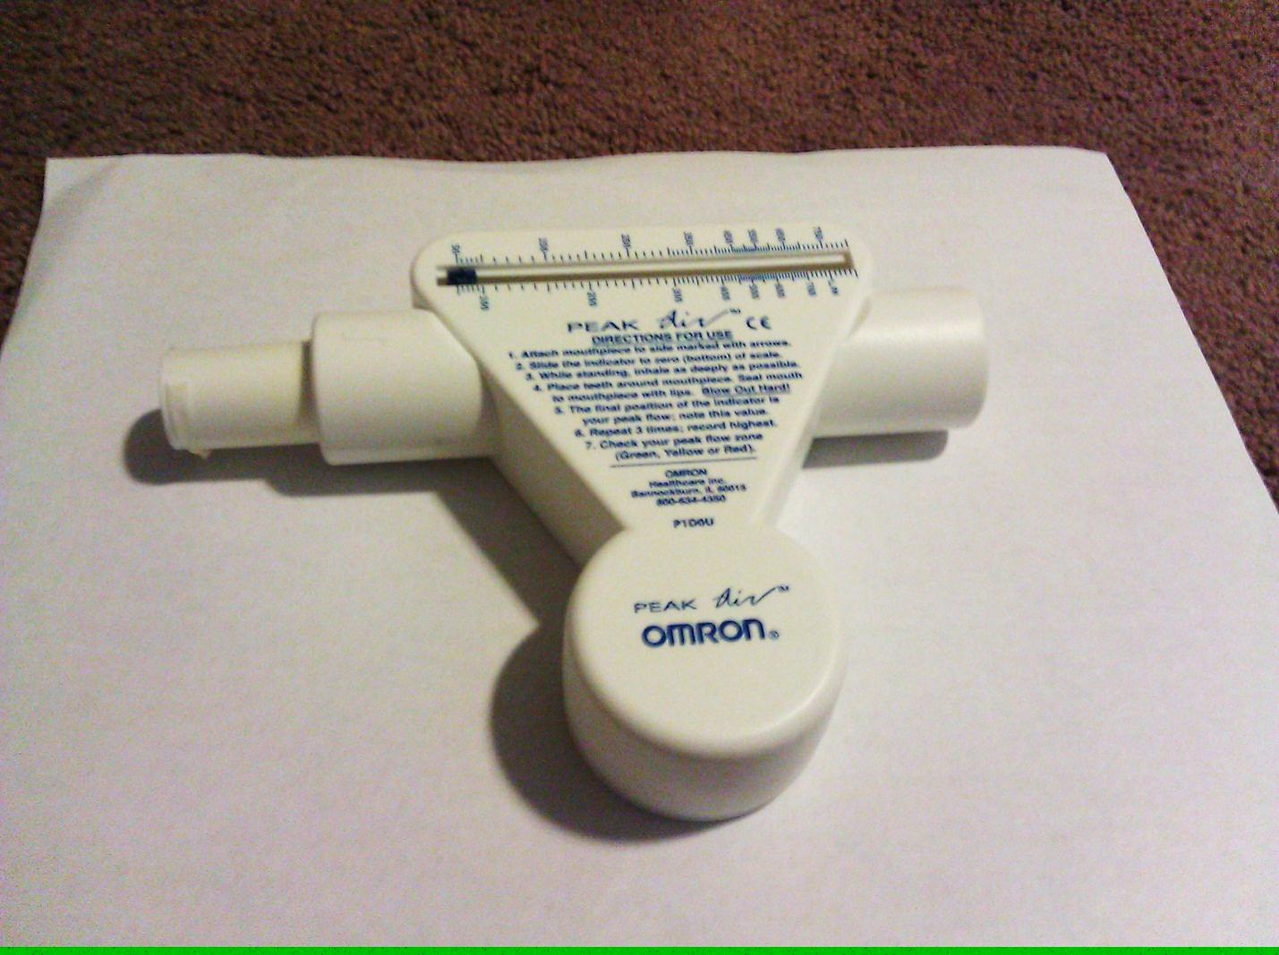

Apparatus being used to measure the airflow rate.

*Not drawn to scale*

I will repeat this experiment for five iterations for each test subject before beginning the next trial. Each successive trial will allow me to test the next target area’s subject, and each trial will have five iterations. The experiment will be concluded when five trials are completed.

The targeted groups are as such:

* Short Sprinter (100m)
* Long Sprinter (200m)
* Mid-Distance Runner (3k)
* Long Distance Runner (5k)
* Thrower (throwing of heavy balls)

Target Group vs. Airflow Rate

|  |  |  |  |  |  |  |
| --- | --- | --- | --- | --- | --- | --- |
|  |  |  | **Male** | | **Female** | |
| **Trial** | **Target Group** | **Avg. Distance Ran in Competition** d / m | **Airflow Rate** R / L/m ∆R = ± 10 L/m | **Avg. Airflow Rate** ∆R = ± 80 L/m | **Airflow Rate** R / L/m ∆R = ± 10 L/m | **Avg. Airflow Rate** ∆R = ± 90 L/m |
| 1 | Short Sprinter (100m) | 100.0 | 540 | 526 | 270 | 326 |
| 520 | 300 |
| 520 | 340 |
| 530 | 360 |
| 520 | 360 |
| 2 | Long Sprinter (200m) | 200.0 | 560 | 558 | 330 | 354 |
| 570 | 350 |
| 540 | 370 |
| 560 | 360 |
| 560 | 360 |
| 3 | Mid Distance (3k) | 3000.0 | 520 | 528 | 540 | 432 |
| 530 | 500 |
| 530 | 360 |
| 520 | 360 |
| 540 | 400 |
| 4 | Long Distance (5k) | 5000.0 | 510 | 446 | 330 | 354 |
| 440 | 350 |
| 440 | 370 |
| 450 | 360 |
| 390 | 360 |
| 5 | Thrower | NaN | 770 | 668 | 390 | 392 |
| 610 | 380 |
| 650 | 400 |
| 660 | 390 |
| 650 | 400 |

The average airflow uncertainty was calculated by taking half the range of each trial’s airflow values. I did this for each set of numbers and took the highest one.

The measurement for the airflow values is liters per minute.

I made this chart so that I would be able to quickly determine the general trend of the relationships being presented. From this graph, we can see that that the females generally had a lower airflow rate than their male counterparts. This was expected to be because men are generally more naturally athletic than females. Across the graph we can see that it goes up from the short distances but then drops off for the long distances. These observations give support my original hypothesis which is the shorter the distance you run the faster the airflow rate will be for an individual. To further ascertain the relationship between these two variables, I created another chart that uses quantitative data rather than qualitative data.

The best fit line of the male graph has a gradient of -0.0174. This suggests that my hypothesis is correct which is that the shorter the distance you run, the higher the airflow rate will be. Using a linear fit line, I have an R2 value of -0.7352, which means that I have a correlation coefficient -85.7%. This is not statically significant but it demonstrates what I believe that the relationship was and is. As well, the best fit line of the female graph has a gradient of -0.005. This also suggests a negative trend which gives support for my hypothesis. This graph also has an R2 value of -0.6890 which means I have a correlation coefficient of -83.0%. This coefficient is also statically insignificant but it still gives me support for my original hypothesis because it suggests a negative trend. Because of the consistency of the data between the target groups and between males and females gives support and me hope about my hypothesis and the accuracy of my data.

Male:

The male best fit gradient is calculated to be -0.0174.

Calculating male maximum and minimum gradients:

Maximum gradient = (680 – 530) / (3000 – 100) = 0.0517

Minimum gradient = (630 – 590) / (3000 – 100) = 0.0138

The male gradient uncertainty would be 1/2(0.0517 – 0.0138) = 0.0189.

Therefore the male gradient is calculated to be **-0.0174 ± 0.0189.**

Female:  
 The female best fit gradient is calculated to be -0.0050.

Calculating female maximum and minimum gradients:

Maximum gradient = (560– 240) / (3000 – 100) = 0.110

Minimum gradient = (520 – 280) / (3000 – 100) = 0.0827

The female gradient uncertainty would be 1/2(0.110– 0.0827) = 0.0189.

Therefore the female gradient is calculated to be **-0.0050 ± 0.0136.**

According to my data, there exists a relation between the type of exercise that you regularly participate in and your lung airflow rate. The relation is as such: the shorter the distances that you run, typically the faster your airflow rate will be. I do not think that this relationship can be calculated with the amount of data, but the conclusion can be drawn from the data because when I tested the two test groups, this trend was followed in both the males and females. As well, this now makes sense because the short distance sprinters have a need of circulating oxygen through their system quickly because their muscles are exerting a lot of force in a small amount of time. Being able to get oxygen through the system rather fast would be beneficiary for the runner and it comes through training. I have taken repeated measurements for each trial performed. To account for systematical errors, I had to explain to the participants of how to blow into the apparatus correctly.

Throughout the course of the experiment, there were some problems that could have affected the results of my data. The variable that presented the most affect was the apparatus that I used to measure the individuals airflow rate. This device requires the individual to blow into the tube in a very specific manner, and this was quite hard to teach to the participant. So, the participants blew into the tube in different styles sometimes which could have affected the results of my experiment. As well, I tried to measure the airflow rates of the individuals after they have performed their warm-ups, but since I was taking the measurements from ten different people, I was unable to insure that one individual did not get more warm-up time than another person.

Since the random error represents the largest uncontrolled uncertainty, I must modify my procedure to reduce or eliminate its effect. I propose asking the participants to stagger their warm-up activities. In other words, a group of three would begin their warm-ups and then you measure there airflow rates. After that the next group would begin warming and then you could measure their airflow rates and so on until all the participants have been measured. This eliminates the effect of when you stated the warm-up time as a factor that affects the individual’s airflow rate. This proposal would eliminate the random error of this experiment and provide more accurate results.